**Terraform Task**

**Setting Up A Terraform Backend Using Amazon S3 and DynamoDB**

**Name – Shashank Sharma**

1. **Create a S3 bucket in the AWS.**

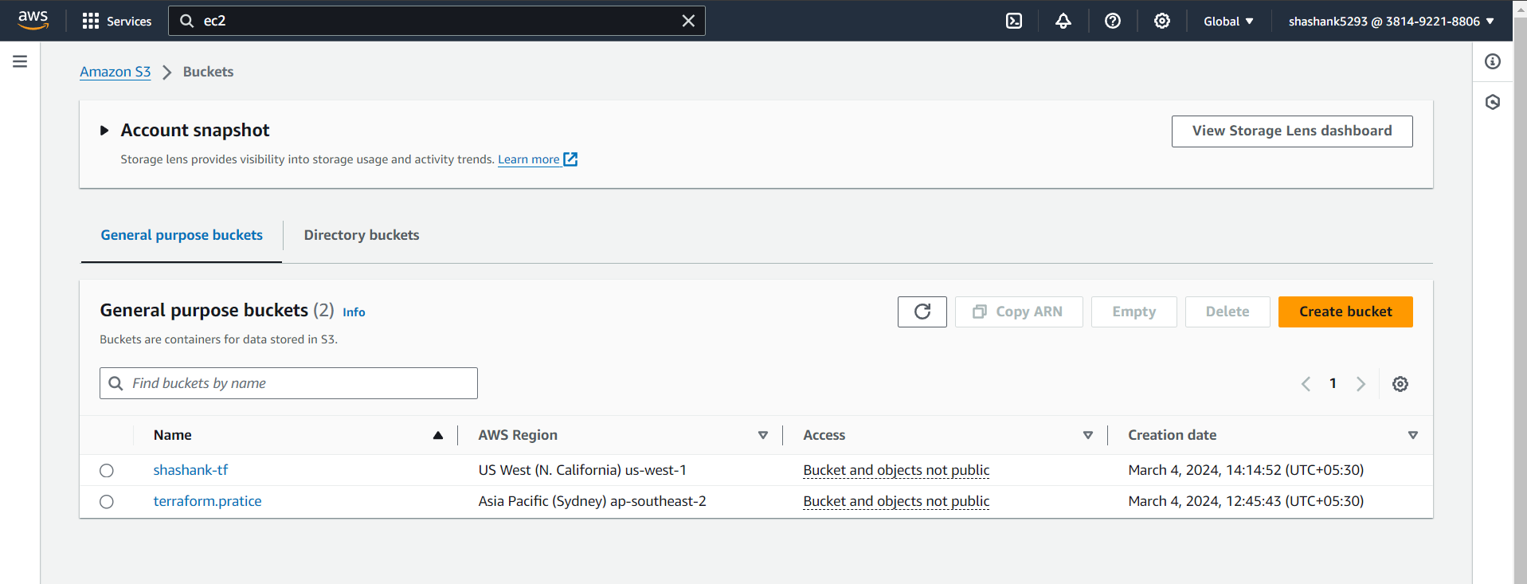

1. **Create a DynomoDB Table in AWS.**

**Give The Partition Key**

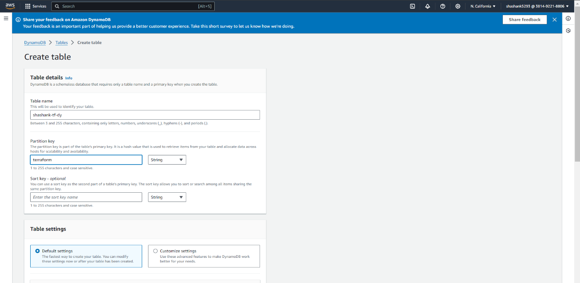

1. **Open Your VS Code Add Script Of Terraform Backend.**
2. **Make Changes As Per Your Bucket Name , DynamoDB Table Name, Region & Shared_Credentials_Files [“”].**

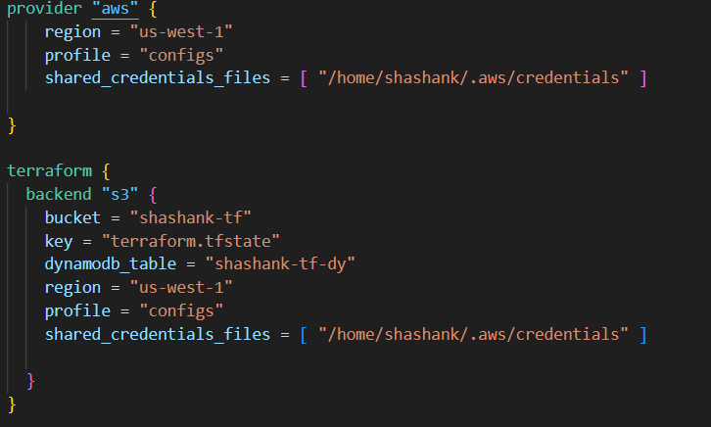

1. **After Creating Bucket & DynamoDB Table Go To The Your Ubuntu Terminal And Install -> awscli**

**Command- sudo apt install awscli**

1. **Then Go To The Next Command For The Your .aws File**

**Command- aws configure –profile configs**

1. **After Completing This It Shows To Put Your Access key & Secret Access Key.**
2. **Enter Your Access key & Secret Access Key.**
3. **After Entering Access key & Secret Access Key You Can Skip The Region & Output Format.**
4. **Use Following Commands For The Further Steps.**

**ls -a**

**cd .aws**

**ls**

**pwd**

**-> It Give The Path Which Is Your Should Be Copy And Paste It in Terraform Script.**

**-> My Path Is /home/Shashank/.aws**

**-> Copy This Path & paste In Shared_Credentials_Files[“”]**

**-> With The Addition Of Credentials**

**-> Final Path is = /home/Shashank/.aws/credentials**

**cd /mnt**

**ls**

**cd Shashank**

**ls**

**cd terraform-demo**

**ls**

**cd terraform-backend**

**ls**

**terraform init**

**terraform plan**

**terraform graph**

**terraform fmt**

**terraform apply**

**->While Terraform Applying If You Face Error Like This**

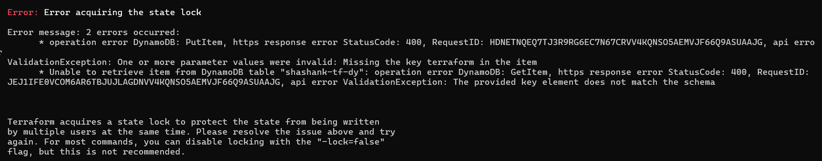

**Use This Command To Solve The Error**

**Command – terraform apply -lock=false**

**Then Error Will Be Solve**

1. **Go -> aws -> s3 Bucket**
2. **The File Is Created .**
3. **Open The File It Gives O/p.**

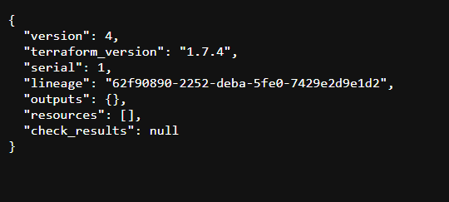

1. **To Make A Version Of The File Make Changes In The Script.**

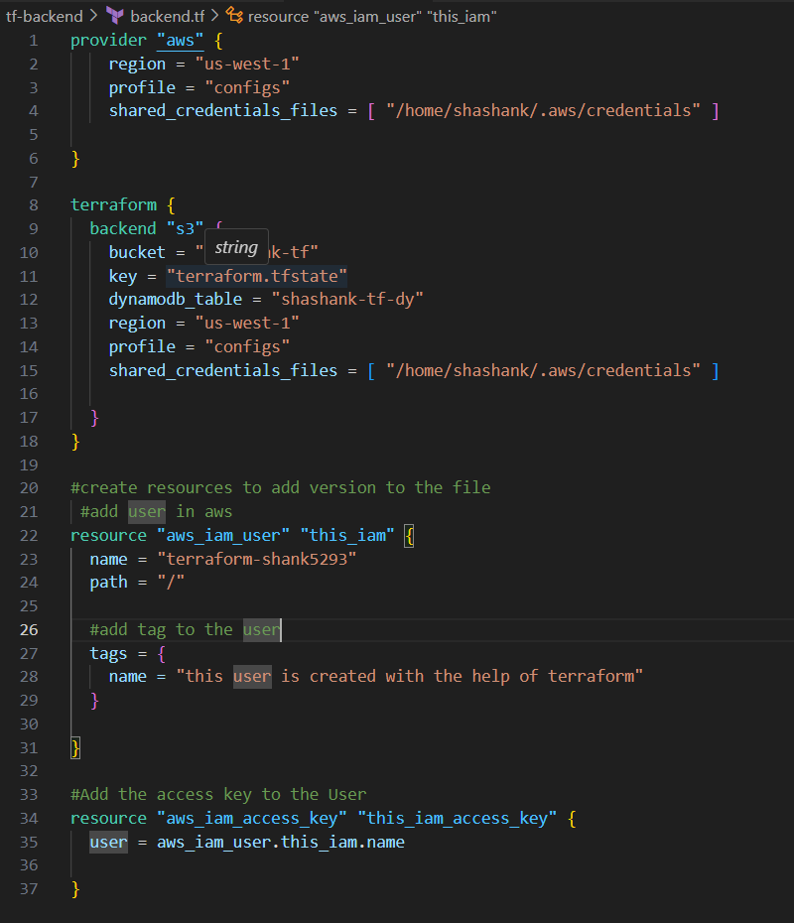

1. **After Making Some Changes It Shows File Versions.**

